**Chapter 1**

**INTRODUCTION**

A database management system (DBMS) refers to the technology for creating and managing databases. Basically DBMS is a software tool to organize (create, retrieve, update and manage) data in a database.

The main aim of a DBMS is to supply a way to store up and retrieve database information that is both convenient and efficient. By data, we mean known facts that can be recorded and that have embedded meaning. Normally people use software such as DBASE IV or V, Microsoft ACCESS, or EXCEL to store data in the form of database.

Database systems are meant to handle large collection of information. Management of data involves both defining structures for storage of information and providing mechanisms that can do the manipulation of those stored information. Moreover, the database system must ensure the safety of the information stored, despite system crashes or attempts at unauthorized access.

This project aims at computerizing the manual process of storage system. Front end and backend are implemented using HTML , MySQL, PHP and NODEJS respectively. Along with the JSP program to analyze the program. The project consists of four types of Application forms for Criminal record, Prisoner record, Police database management, Complaint registration. It also consists of a Home Page, Contact us, Login page and Regestration Page

**The Highlighted Features of The Project includes**

**1.** A good view interface to the users.

**2.** A complaint registration page which can be retrieve for the further .

**3.** A police data storage and retrieve further usage.

**4.** A criminal record database store and retrieve for further usage.

**5.** A Prisoner Data database store and retrieve for further usage.

**6.** A Case Data database store and retrieve for further usage.

**Chapter 2**

**REQUIREMENTS SPECIFICATIONS**

**2.1 Functional Requirements :**

* CREATE POLCE DATA
* CREATE PRISONERS DATA
* CREATE CRIMINAL DATA
* COMPLAINTS DATA
* CASE DATA

**2.2 Non-Functional Requirements :**

* **OPERATING SYSTEM :** WINDOWS
* **DATABASE :** SQL
* **DEVELOPMENT TOOLS &**

**PROGRAMMING LAUNGUAGES :** HTML5 , CSS, PHP, SQL , NODE.JS , JAVA ,JS..ETC

* **PROCESSOR :**  DUAL CORE 2.5GHZ
* **MEMORY :**  1 GB
* **HARD DISC :** MINIMUM 80GB HARD DISK

**2.3 Data Requirements**

* FOR THE NEW ENTRY OF POLICE DATA
* ID
* NAME
* DSIGNATION
* CASE_NO
* FOR THE NEW ENTRY OF PRISONER DATA
* PRISONER_ID
* PRISONER_NAME
* PRISONER_CASE
* DATE_ARREST
* FOR THE NEW ENTRY OF CRIMINAL DATA
* CRIMINAL_ID
* CRIMINAL_NAME
* CRIME
* DATE_COMMITED
* FOR THE NEW ENTRY OF COMPLAINTS DATA
* COMPLAINT_ID
* COMPLAINT_NAME
* DESCRIPTION
* DATA_REG
* FOR THE NEW ENTRY OF CASE DATA
* CASE_ID
* CASE_NAME
* DESCRIPTION
* DATE_UPDATE

**Chapter 3**

**DESIGN**

**3.1 ER Diagram**

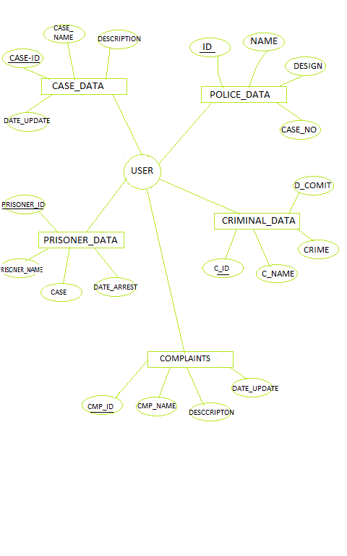

Fig no. 1

**3.2 Schema Diagram**

**POLICE_DATA**

|  |  |  |  |
| --- | --- | --- | --- |
| **ID** | NAME | DESIGN | CASE_HANDLE |

**PRISON**

|  |  |  |  |  |
| --- | --- | --- | --- | --- |
| **PRISONER_ID** | PRISONER_NAME | PRISONER_CASE | DATE_ARREST | DATE_RELEASE |

**CRIMINAL**

|  |  |  |  |
| --- | --- | --- | --- |
| **CRIMINAL_ID** | CRIMINAL_NAME | CRIME | DATE_COMMITED |

**COMPLAITS**

|  |  |  |  |  |
| --- | --- | --- | --- | --- |
| **C_ID** | C_NAME | DESCRIPTION | DATA_REG | POLICE_HANDLE |

**CASE_DATA**

|  |  |  |  |
| --- | --- | --- | --- |
| **CASE_ID** | CASE_NAME | DESCRIPTION | DATE-UPDATE |

Fig no.2

**Chapter 4**

**implementation**

The project is implemented using MySQL database along with PHP,CSS, and HTML. In this project, we use the below mentioned concepts for implementing different type of effects like HTML pages to demonstrate on a web page as a stand-alone or web based application

4.1 TABLE CREATION:

* CREATE TABLE `case_data` (

`case_id` int(8) NOT NULL,

`case_name` varchar(30) NOT NULL,

`description` varchar(220) NOT NULL,

`date_update` datetime NOT NULL DEFAULT CURRENT_TIMESTAMP

) ENGINE=MyISAM DEFAULT CHARSET=utf8mb4;

* CREATE TABLE `complaints` (

`cmp_id` int(11) NOT NULL,

`cmp_name` varchar(30) NOT NULL,

`case_no` int(11) NOT NULL,

`Description` varchar(220) NOT NULL,

`date_reg` datetime DEFAULT NULL ON UPDATE CURRENT_TIMESTAMP,

`police_handle` int(11) NOT NULL

) ENGINE=MyISAM DEFAULT CHARSET=utf8mb4;

* CREATE TABLE `criminal` (

`c_id` int(11) NOT NULL,

`c_name` varchar(30) NOT NULL,

`case_no` int(11) NOT NULL,

`date_committed` datetime NOT NULL DEFAULT CURRENT_TIMESTAMP ON UPDATE CURRENT_TIMESTAMP

) ENGINE=MyISAM DEFAULT CHARSET=utf8mb4;

* CREATE TABLE `police_data` (

`id` int(8) NOT NULL,

`name` varchar(30) NOT NULL,

`design` varchar(220) NOT NULL,

`case_handle` int(10) NOT NULL

) ENGINE=MyISAM DEFAULT CHARSET=utf8mb4;

* CREATE TABLE `prison` (

`prisoner_id` int(11) NOT NULL,

`prisoner_name` varchar(30) NOT NULL,

`case_no` int(11) NOT NULL,

`date_arrest` datetime NOT NULL DEFAULT CURRENT_TIMESTAMP ON UPDATE CURRENT_TIMESTAMP,

`date_release` date NOT NULL

) ENGINE=MyISAM DEFAULT CHARSET=utf8mb4;

4.2 STORED PROCEDURE:

* INSERT INTO `case_data` (`case_id`, `case_name`, `description`, `date_update`) VALUES

(1, 'snach', 'chain snaching', '2021-01-21 23:01:05'),

(2, 'robbery', 'house store robbery', '2021-01-21 23:01:51'),

(3, 'murder', 'murder some people', '2021-01-21 23:03:55'),

(4, 'over speed', 'riding vehicle at high speed', '2021-01-21 23:04:52');

* INSERT INTO `complaints` (`cmp_id`, `cmp_name`, `case_no`, `Description`, `date_reg`, `police_handle`) VALUES

(1, 'raju', 2, 'robbery at his house last night', '2021-01-01 00:00:00', 1);

* INSERT INTO `criminal` (`c_id`, `c_name`, `case_no`, `date_committed`) VALUES(1, 'john', 2, '2021-01-21 23:10:36'),

(2, 'jame', 3, '2021-01-21 23:10:36');

* INSERT INTO `police_data` (`id`, `name`, `design`, `case_handle`) VALUES
* (1, 'Ram', 'SI', 1);INSERT INTO `prison` (`prisoner_id`, `prisoner_name`, `case_no`, `date_arrest`, `date_release`) VALUES

(1, 'frddy', 2, '2021-01-21 23:12:37', '2021-10-22'),

(2, 'robby', 4, '2021-01-21 23:12:37', '2022-12-23');

4.3 INSERTING VALUE FROM FRONT END:

<?php

session_start();

$con=mysqli_connect('localhost','root','');

mysqli_select_db($con,'police');

$case_name=$_POST['case_name'];

$description=$_POST['description'];

$date_update=$_POST['date_update'];

$s="select * from case_data where case_name='$case_name' && description='$description' && date_update='$date_update' ";

$result=mysqli_query($con,$s);

$reg="insert into case_data(case_name,description,date_update) values('$case_name','$description','$date_update')";

mysqli_query($con,$reg);

echo "successful";

?>

<?php

session_start();

$con=mysqli_connect('localhost','root','');

mysqli_select_db($con,'police');

$name=$_POST['name'];

$design=$_POST['design'];

$case_handle=$_POST['case_handle'];

$s="select * from police_data where name='$name' && design='$design' && case_handle='$case_handle' ";

$result=mysqli_query($con,$s);

$reg="insert into police_data(name,design,case_handle) values('$name','$design','$case_handle')";

mysqli_query($con,$reg);

?>

<?php

session_start();

$con=mysqli_connect('localhost','root','');

mysqli_select_db($con,'police');

$c_name=$_POST['c_name'];

$case_no=$_POST['case_no'];

$date_committed=$_POST['date_committed'];

$s="select * from criminal where c_name='$c_name' && case_no='$case_no' && date_committed='$date_committed' ";

$result=mysqli_query($con,$s);

$reg="insert into criminal(c_name,case_no,date_committed) values($c_name','$case_no','$date_committed')";

mysqli_query($con,$reg);

?>

<?php

session_start();

$con=mysqli_connect('localhost','root','');

mysqli_select_db($con,'police');

$cmp_name=$_POST['cmp_name'];

$case_no=$_POST['case_no'];

$Description=$_POST['Description'];

$date_reg=$_POST['date_reg'];

$police_handle=$_POST['police_handle'];

$s="select * from complaints where cmp_name='$cmp_name' && case_no='$case_no' && Description='$Description' && date_reg='$date_reg' && police_handle='$police_handle'";

$result=mysqli_query($con,$s);

$reg="insert into complaints(cmp_name,case_no,Description,date_reg,police_handle) values('$cmp_name','$case_no','$Description','$date_reg','$police_handle')";

mysqli_query($con,$reg);

echo "successful";

?>

<?php

session_start();

$con=mysqli_connect('localhost','root','');

mysqli_select_db($con,'police');

$case_name=$_POST['case_name'];

$description=$_POST['description'];

$date_update=$_POST['date_update'];

$s="select * from case_data where case_name='$case_name' && description='$description' && date_update='$date_update' ";

$result=mysqli_query($con,$s);

$reg="insert into case_data(case_name,description,date_update) values('$case_name','$description','$date_update')";

mysqli_query($con,$reg);

echo "successful";

?>

4.4 CALLING STORED PROCEDURE FROM FRONT END:

<!DOCTYPE html>

<html>

<head>

<title>CRIMINAL</title>

<link rel="stylesheet" type="text/css" href="Admission.css">

</head>

<body><center>

<?php

$servername = "localhost";

$username = "root";

$password = "";

$dbname = "police";

// Create connection

$conn = new mysqli($servername, $username, $password, $dbname);

// Check connection

if ($conn->connect_error) {

die("Connection failed: " . $conn->connect_error);

}

$sql = "SELECT c_id, c_name, case_no, date_committed FROM CRIMINAL";

$result = $conn->query($sql);

if ($result->num_rows > 0) {

echo "<table><tr><th>CRIMINAL ID</th><th>CRIMINAL NAME</th><th>CASE NUMBER</th><th>DATE COMMITTED</th></tr>";

// output data of each row

while($row = $result->fetch_assoc()) {

echo "<tr><td>" . $row["c_id"]. "</td><td>" . $row["c_name"]. "</td><td>" . $row["case_no"]. "</td><td>" . $row["date_committed"]. "</td></td>";

}

echo "</table>";

} else {

echo "0 results";

}

$conn->close();

?>

</center>

</body>

</html>

<!DOCTYPE html>

<html>

<head>

<title>POLICE</title>

<link rel="stylesheet" type="text/css" href="Admission.css">

</head>

<body><center>

<?php

$servername = "localhost";

$username = "root";

$password = "";

$dbname = "police";

// Create connection

$conn = new mysqli($servername, $username, $password, $dbname);

// Check connection

if ($conn->connect_error) {

die("Connection failed: " . $conn->connect_error);

}

$sql = "SELECT id, name, design, case_handle FROM police_data";

$result = $conn->query($sql);

if ($result->num_rows > 0) {

echo "<table><tr><th>POLICE ID</th><th>POLICE NAME</th><th>CASE NUMBER</th><th>CASE HANDLING</th></tr>";

// output data of each row

while($row = $result->fetch_assoc()) {

echo "<tr><td>" . $row["id"]. "</td><td>" . $row["name"]. "</td><td>" . $row["design"]. "</td><td>" . $row["case_handle"]. "</td></td>";

}

echo "</table>";

} else {

echo "0 results";

}

$conn->close();

?>

</center>

</body>

</html>

<!DOCTYPE html>

<html>

<head>

<title>CRIMINAL</title>

<link rel="stylesheet" type="text/css" href="Admission.css">

</head>

<body><center>

<?php

$servername = "localhost";

$username = "root";

$password = "";

$dbname = "police";

// Create connection

$conn = new mysqli($servername, $username, $password, $dbname);

// Check connection

if ($conn->connect_error) {

die("Connection failed: " . $conn->connect_error);

}

$sql = "SELECT prisoner_id, prisoner_name, case_no, date_arrest, date_release FROM prison";

$result = $conn->query($sql);

if ($result->num_rows > 0) {

echo "<table><tr><th>PRISONER ID</th><th>PRISONER NAME</th><th>CASE NUMBER</th><th>DATE ARREST</th><th>DATE RELEASE</th></tr>";

// output data of each row

while($row = $result->fetch_assoc()) {

echo "<tr><td>" . $row["prisoner_id"]. "</td><td>" . $row["prisoner_name"]. "</td><td>" . $row["case_no"]. "</td><td>" . $row["date_arrest"]. "</td><td>" . $row["date_release"]. "</td></td>";

}

echo "</table>";

} else {

echo "0 results";

}

$conn->close();

?>

</center>

</body>

</html>

<!DOCTYPE html>

<html>

<head>

<title>COMPLAINT</title>

<link rel="stylesheet" type="text/css" href="Admission.css">

</head>

<body><center>

<?php

$servername = "localhost";

$username = "root";

$password = "";

$dbname = "police";

// Create connection

$conn = new mysqli($servername, $username, $password, $dbname);

// Check connection

if ($conn->connect_error) {

die("Connection failed: " . $conn->connect_error);

}

$sql = "SELECT cmp_id, cmp_name, case_no, Description, date_reg, police_handle FROM complaints";

$result = $conn->query($sql);

if ($result->num_rows > 0) {

echo "<table><tr><th>COMPLAINT ID</th><th>COMPLAINT NAME</th><th>CASE NUMBER</th><th>DATE REGESTIRED</th><th>HANDLED BY</th></tr>";

// output data of each row

while($row = $result->fetch_assoc()) {

echo "<tr><td>" . $row["cmp_id"]. "</td><td>" . $row["cmp_name"]. "</td><td>" . $row["Description"]. "</td><td>" . $row["date_reg"]. "</td><td>" . $row["police_handle"]. "</td></tr>";

}

echo "</table>";

} else {

echo "0 results";

}

$conn->close();

?>

</center>

</body>

</html>

**Codes**

**Case_Entry.html(form)**

<!DOCTYPE html>

<html>

<head>

<title>CASE ENTRY</title>

<link rel="stylesheet" type="text/css" href="Admission.css">

<script type="text/javascript" src="admission.js"></script>

</head>

<body>

<div class="box">

<h3>CASE ENTRY</h3>

<form >

<input type="name" id="name" name="id" placeholder="CASE-ID" required="" >

<input type="name" id="name" name="name" placeholder="CASE-NAME" required="" >

<input type="name" id="Desig" name="Desig" placeholder="DSCRIPTION" required="" >

<input type="number" id="number" name="Case_no" placeholder="Case_no" required="">

<input type="Submit" name="submit" onclick="msg1();msg2()">

</form>

</div>

</body>

</html>

**Complaint-entry.html**

<!DOCTYPE html>

<html>

<head>

<title>COMPLAINT FORM</title>

<link rel="stylesheet" type="text/css" href="Admission.css">

<script type="text/javascript" src="admission.js"></script>

</head>

<body>

<div class="box">

<h3>COMPLAINT FORM</h3>

<form >

<input type="name" id="name" name="id" placeholder="COMPLAINT-ID" required="" >

<input type="name" id="name" name="name" placeholder="COMPLAINT-NAME" required="" >

<input type="name" id="name" name="Desig" placeholder="DESCRIPTION" required="" >

<input type="name" id="name" name="DATE-REGESTERED" placeholder="DATE-REGESTERED" required="" >

<input type="Submit" name="submit" onclick="msg1();msg2()">

</form>

</div>

</body>

</html>

**complaint-entry.html**

<!DOCTYPE html>

<html>

<head>

<title>COMPLAINT FORM</title>

<link rel="stylesheet" type="text/css" href="Admission.css">

<script type="text/javascript" src="admission.js"></script>

</head>

<body>

<div class="box">

<h3>COMPLAINT FORM</h3>

<form >

<input type="name" id="name" name="id" placeholder="ID" required="" >

<input type="name" id="name" name="name" placeholder="name" required="" >

<input type="Desig" id="Desig" name="Desig" placeholder="Dscription" required="" >

<input type="number" id="number" name="Case_no" placeholder="Case_no" required="" maxlength='10' >

<input type="Submit" name="submit" onclick="msg1();msg2()">

</form>

</div>

</body>

</html>

**Criminal-entry.html**

<!DOCTYPE html>

<html>

<head>

<title>CRINIMAL ENTRY</title>

<link rel="stylesheet" type="text/css" href="Admission.css">

<script type="text/javascript" src="admission.js"></script>

</head>

<body>

<div class="box">

<h3>CRINIMAL ENTRY</h3>

<form >

<input type="name" id="name" name="id" placeholder="CRIMINAL-ID" required="" >

<input type="name" id="name" name="name" placeholder="CRIMINAL-NAME" required="" >

<input type="name" id="Desig" name="Desig" placeholder="CRIME" required="" >

<input type="number" id="number" name="Case_no" placeholder="DATE_COMMITED" required="" >

<input type="Submit" name="submit" onclick="msg1();msg2()">

</form>

</div>

</body>

</html>

**Police-entry.html**

<!DOCTYPE html>

<html>

<head>

<title>POLICE ENTRY</title>

<link rel="stylesheet" type="text/css" href="Admission.css">

<script type="text/javascript" src="admission.js"></script>

</head>

<body>

<div class="box">

<h3>POLICE ENTRY</h3>

<form >

<input type="name" id="name" name="id" placeholder="ID" required="" >

<input type="name" id="name" name="name" placeholder="name" required="" >

<input type="name" id="Desig" name="Desig" placeholder="Designation" required="" >

<input type="number" id="number" name="Case_no" placeholder="Case_no" required="" >

<input type="Submit" name="submit" onclick="msg1();msg2()">

</form>

</div>

</body>

</html>

**Police-logon.html**

<!DOCTYPE html>

<html>

<head>

<title>POLICE LOG</title>

<link rel="stylesheet" type="text/css" href="Admission.css">

<script type="text/javascript" src="admission.js"></script>

</head>

<body>

<div class="box">

<h3>POLICE LOG</h3>

<form >

<input type="name" id="name" name="id" placeholder="ID" required="" >

<input type="name" id="name" name="name" placeholder="name" required="" >

<input type="Desig" id="Desig" name="Desig" placeholder="Designation" required="" >

<input type="number" id="number" name="Case_no" placeholder="Case_no" required="" maxlength='10' >

<input type="Submit" name="submit" onclick="msg1();msg2()">

</form>

</div>

</body>

</html>

**Prison-entry.html**

<!DOCTYPE html>

<html>

<head>

<title>PRISON ENTRY</title>

<link rel="stylesheet" type="text/css" href="Admission.css">

<script type="text/javascript" src="admission.js"></script>

</head>

<body>

<div class="box">

<h3>PRISON ENTRY</h3>

<form >

<input type="name" id="name" name="id" placeholder="PRISONER-ID" required="" >

<input type="name" id="name" name="name" placeholder="PRISONER-NAME" required="" >

<input type="name" id="Desig" name="Desig" placeholder="PRISONER-CASE" required="" >

<input type="number" id="number" name="Case_no" placeholder="DATE-ARREST" required="">

<input type="Submit" name="submit" onclick="msg1();msg2()">

</form>

</div>

</body>

</html>

**Contact.html**

-<html>

<head>

<title>Police Station Management Database System</title>

<style type="text/css">

.style5711 {

font-size: 12px;

font-weight: bold;

font-family: Verdana, Arial, Helvetica, sans-serif;

}

.style57111 {font-size: 9px; font-weight: bold; font-family: Verdana, Arial, Helvetica, sans-serif; }

.style57111 {font-size: 12px;

font-weight: bold;

font-family: Verdana, Arial, Helvetica, sans-serif;

}

.style57112 {font-size: 9px; font-weight: bold; font-family: Verdana, Arial, Helvetica, sans-serif; }

.style571111 {font-size: 12px;

font-weight: bold;

font-family: Verdana, Arial, Helvetica, sans-serif;

}

h1 {

color: Linel;

text-align: center;

}

ul {

list-style-type: none;

margin: 0;

padding: 0;

overflow: hidden;

background-color: #333;

}

li {

float: left;

}

li a {

display: inline-block;

color: white;

text-align: center;

padding: 14px 16px;

text-decoration: none;

}

li a:hover {

background-color: #111;

}

div.img {

margin: 5px;

border: 1px solid #ccc;

float: left;

width: 180px;

}

div.img:hover {

border: 1px solid #777;

}

div.imgimg {

width: 100%;

height: auto;

}

div.desc {

padding:15px;

text-align: center;

}

</style>

</head>

<body background="leather.gif" leftmargin="0" topmargin="0" marginwidth="0" marginheight="0">

<table width="980" border="0" align="center" cellpadding="0" cellspacing="0" bgcolor="#FFFFFF">

<tr>

<td width="313"><table width="980" border="0" cellspacing="0" cellpadding="0">

<tr>

<td width="181"><imgsrc="image4.jpg" width="231" height="270"></td>

<td width="121"><imgsrc="image2.jpg" width="518" height="270"></td>

</tr>

</table></td>

</tr>

<tr><td><table width="980" border="0"cellspacing="0" cellpadding="0">

<tr><ul>

<li><a class="active" href="frame.html">Home</a></li>

<li><a href="code.html" class="style5711">About</a></li>

</ul>

</tr>

</table>

</td>

</tr>

<tr>

<td height="7" background="home.jpg"></td>

</tr>

<tr>

<td align="center" background="b5.jpg" style="font-size:30px; font-weight:bold;font-style:italic;font-color:blue">Contact us</td>

</tr>

<table width="800" border="2" align="center" cellpadding="0" cellspacing="0" background="b5.jpg">

<tr>

<td width="800"><table width="800" border="0" align="center" cellspacing="5" cellpadding="5">

<tr><td width="200"><imgsrc="venky.jpg" width="350" height="300"><div class="desc">&nbsp<strong>venky</strong><br />

<strong>5th Sem CSE,<br />

SDM Educational Society (R)<br />

Dharmasthala Road<br />

Ujire, D.K- 574240</strong></p>

<p>Call :9945985413 <br />

E-mail :amulya@gmail.com</div>

</div>

</td>

<td width="200"><imgsrc="suraj.jpg" width="350" height="300"><div class="desc"><strong>Suraj S</strong><br />

<strong>5th Sem CSE,<br />

City Engineering College(vtu)<br />

Bangalore<br />

Karnataka</strong></p>

<p>Call :9071312605<br />

E-mail : surajpriya@gmail.com</div>

</div>

</td>

</tr>

</table></td></tr>

</hr>

</body>

</html>

**Home.html**

<html>

<head>

<title>Police Station Management System</title>

<link href="style.css" rel="stylesheet" type="text/css">

<script language="JavaScript" type="text/javascript" src="menu-list.js"></script>

<script src="SpryAssets/SpryMenuBar.js" type="text/javascript"></script>

<style type="text/css">{

size: 12px;

}

li a:link {

text-decoration: none;

color: #666;

}

li a:visited {

text-decoration: none;

}

li a:hover {

text-decoration: none;

}

li a:active {

text-decoration: none;

color: #666;

font-size: 13px;

}

.style5711 {

font-size: 20px;

font-weight: bold;

font-family: Verdana, Arial, Helvetica, sans-serif;

}

.style571111 {font-size: 20px;

font-weight: bold;

font-family: Verdana, Arial, Helvetica, sans-serif;

}

h{

color: blue; font-size:30px; }

ul {

list-style-type: none;

margin: 0;

padding: 0;

overflow: hidden;

background-color: #333;

}

li {

float: left;

}

li a {

display: inline-block;

color: white;

text-align: center;

padding: 14px 16px;

text-decoration: none;

}

li a:hover {

background-color: #111;

}

</style>

</head>

<body background="" leftmargin="0" topmargin="0" marginwidth="0" marginheight="0">

<table width="980" border="0" align="center" cellpadding="0" cellspacing="0" bgcolor="#FFFFFF">

<tr>

<td width="313"><table width="980" border="0" cellspacing="0" cellpadding="0">

<tr>

<td width="300"><imgsrc="image4.jpg" width="300" height="200"></td>

<td width="680"><imgsrc="image2.jpg" width="680" height="200"></td>

</tr>

</table></td>

</tr>

<tr>

<td><table width="980" border=" " cellspacing="0" cellpadding="0">

<tr>

<td bgcolor="#22222"><ul>

<li><a href="code.html"class="style5711">About</a></li>

<li><a href="login.php" class="style5711">Login</a></li>

<li><a href="contact.html" class="style5711">Contact</a></li>

</tr>

</table></td>

</tr>

<tr>

<td height="180" background="image18.jpg"></td></tr>

<tr>

<td height="33" width="500" background="bg19.jpg"><h1><marquee id='scroll_news' style="font-family:Book Antiqua; color:#ffffff"><div onMouseOver="document.getElementById('scroll_news').stop();" onMouseOut="document.getElementById('scroll_news').start();">Police Station Management System </div></marquee></h1></td>

</tr>

<table align="center" width="980" border="0" cellspacing="0" cellpadding="0">

<td width="795" valign="top"<div align="justify" ><span class="text-Italic" style="color:#000000" ><h3>&nbsp&nbsp&nbsp&nbsp&nbsp The safety and protection of human rights has been remained the most important issue for every country because until and unless the rights of human beings are not protected, no country can imagine of its existance.It is the responsibility of every country's government to protect the freedom and rights of all human beings with no discrimination so that every individual can lead his life with his own choice without violating the rules and regulations set by the government of the country.

<p>&nbsp&nbsp&nbsp&nbsp&nbsp Although the government responsibility to safegaurd human rights but to take care of human rights was not convinient for the government.So in order to fulfill this task, government formed a special flatform for that purpose known as POLICE STATION. In this way,the responsibility to protect the human rights was handed over to the Police Officers. </p></h3>

</span></div></td>

</tr>

</table></td>

</tr>

</body>

</html>

**Start.html**

<!DOCTYPE html>

<html>

<head>

<style>

* {

box-sizing: border-box;

padding: 2px;

}

body {

font-family: Arial;

padding: 10px;

background: #f2f2f2;

}

/* Header/Blog Title */

.header {

padding: 30px;

text-align: center;

background: #FFF;

}

.header h1 {

font-size: 50px;

}

/* Style the top navigation bar */

.topnav {

overflow: hidden;

background-color: #333;

}

/* Style the topnav links */

.topnav a {

float: left;

display: block;

color: #f2f2f2;

text-align: center;

padding: 14px 16px;

text-decoration: none;

}

/* Change color on hover */

.topnav a:hover {

background-color: #ddd;

color: black;

}

/* Create two unequal columns that floats next to each other */

/* Left column */

.leftcolumn {

float: left;

width: 75%;

}

/* Right column */

.rightcolumn {

float: left;

width: 25%;

background-color: #f1f1f1;

padding-left: 20px;

}

/* Fake image */

.fakeimg {

background-color: #f1f1f1;

width: 100%;

padding: 20px;

}

/* Add a card effect for articles */

.card {

background-color: white;

padding: 20px;

}

/* Clear floats after the columns */

.row:after {

content: "";

display: table;

clear: both;

}

/* Footer */

.footer {

padding: 20px;

text-align: center;

background: #ddd;

}

/* Responsive layout - when the screen is less than 800px wide, make the two columns stack on top of each other instead of next to each other */

@media screen and (max-width: 800px) {

.leftcolumn, .rightcolumn {

width: 100%;

padding: 0;

}

}

/* Responsive layout - when the screen is less than 400px wide, make the navigation links stack on top of each other instead of next to each other */

@media screen and (max-width: 400px) {

.topnav a {

float: none;

width: 100%;

}

}

</style>

</head>

<body>

<div class="header">

<h1>Police Station Management System</h1>

<p> </p>

</div>

<div class="topnav">

<a href="#">POLICE STATION INFORMATION</a>

<a href="#">POLICE</a>

<a href="./COMPLAINT-ENTRY/complaint-entry.html">COMPLAINT</a>

<a href="#" style="float:right">HOME</a>

</div>

<div class="row">

<div class="leftcolumn">

<div class="card">

<div class="fakeimg" background="leather.gif" style="height:300px;"><imgsrc="image18.jpg" width="300" height="200"><imgsrc="b25.jpg" width="300" height="200"></div>

</div>

<div class="card">

<h2>TITLE HEADING</h2>

<h5>Title description, 2020</h5>

<div class="fakeimg" style="height:200px;">Image</div>

</div>

</div>

<div class="rightcolumn">

<div class="card">

<h2>About Me</h2>

<div class="fakeimg" style="height:100px;">Image</div>

<p>Some text about me in culpa qui officiadeseruntmollitanim..</p>

</div>

<div class="card">

<h3>Popular Post</h3>

<div class="fakeimg"><p><imgsrc="image4.jpg" width="200" height="200"></p></div>

<div class="fakeimg"><p><imgsrc="image2.jpg" width="200" height="200"></p></div>

<div class="fakeimg"><p><imgsrc="b18.jpg" width="200" height="200"></p></div>

</div>

<div class="card">

</div>

</div>

</div>

</body>

</html>

**Chapter 5**

**SNAPSHOTS:**

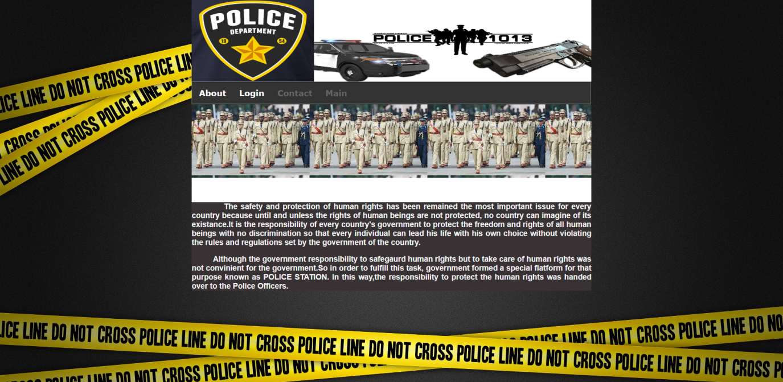

Fig no. 3

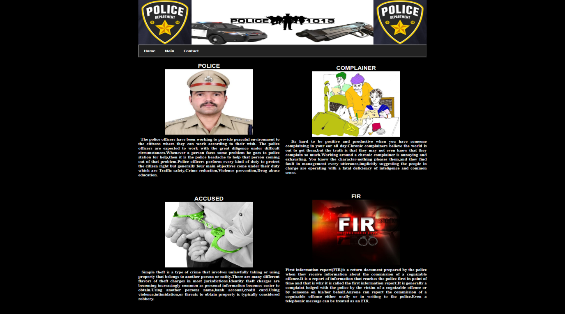

Fig no.4

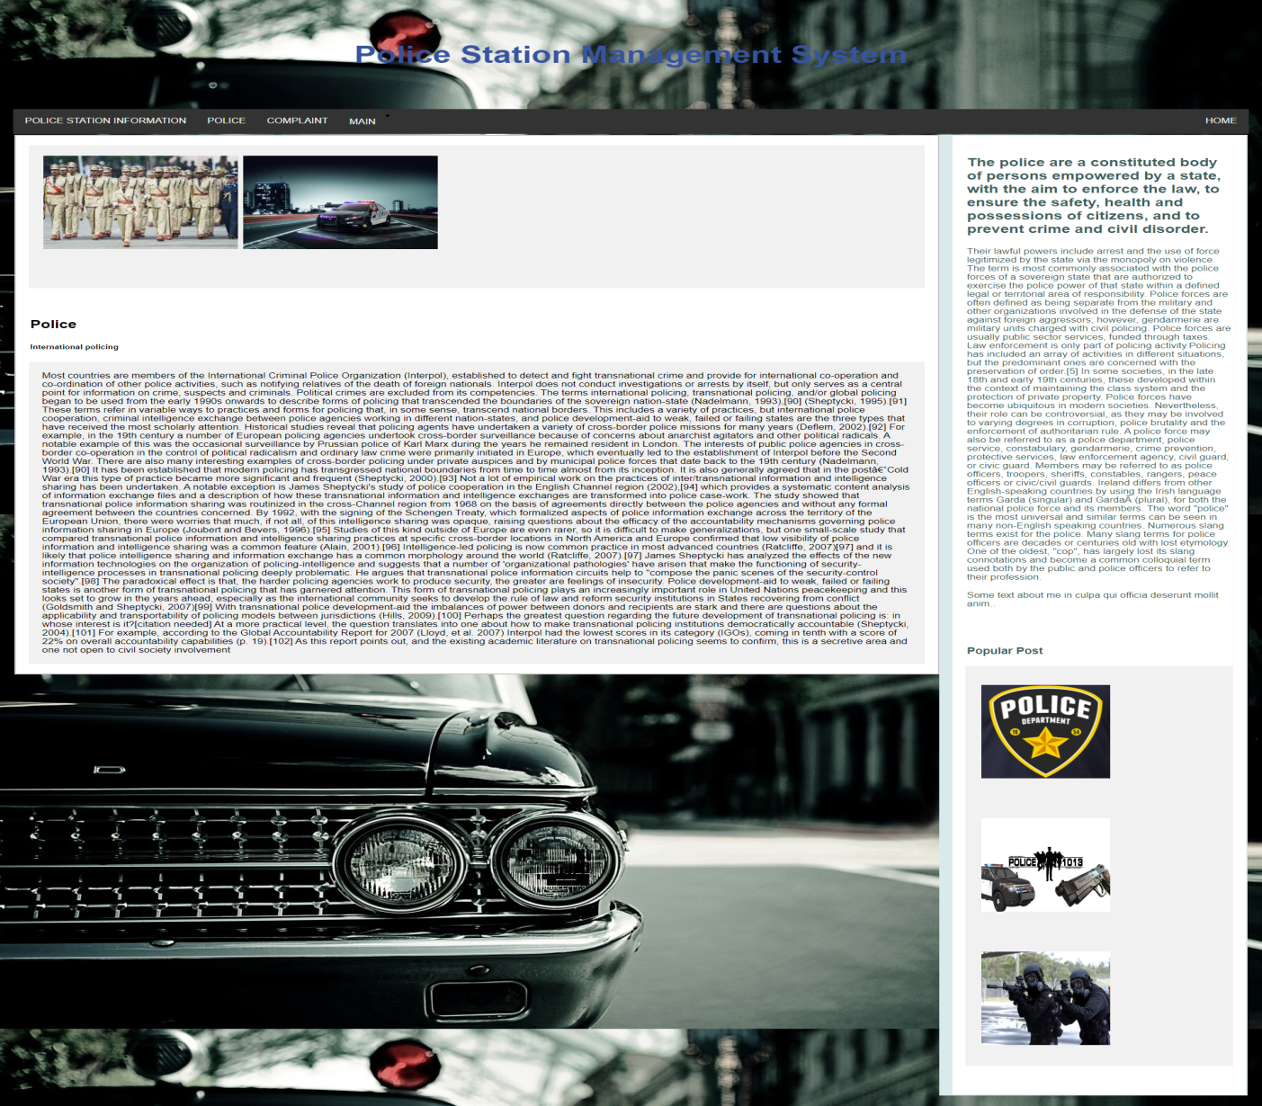

Fig no. 5

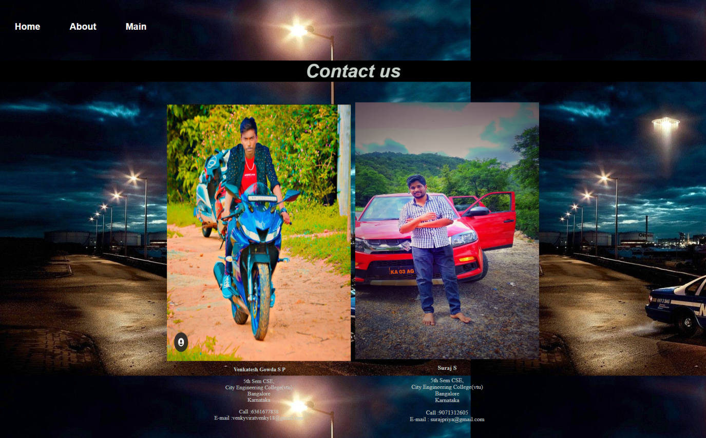

Fig no.6



Fig no.7

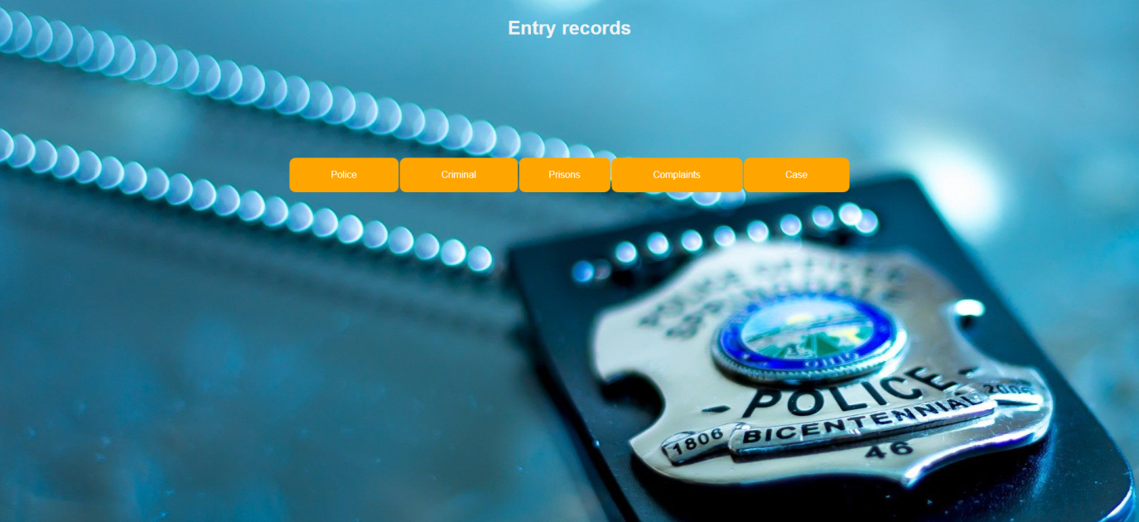

Fig no. 8



Fig no. 9

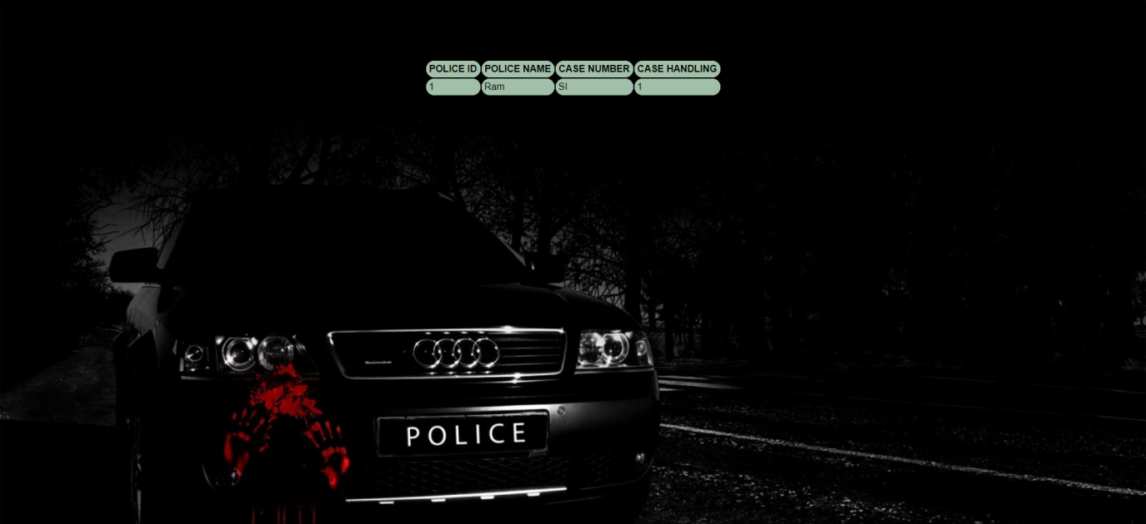

Fig no. 10

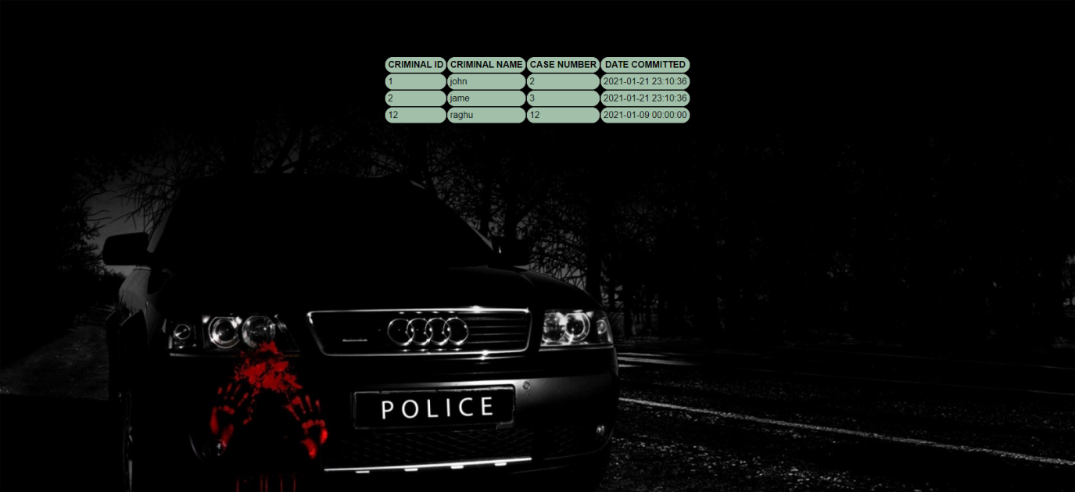

Fig no.11

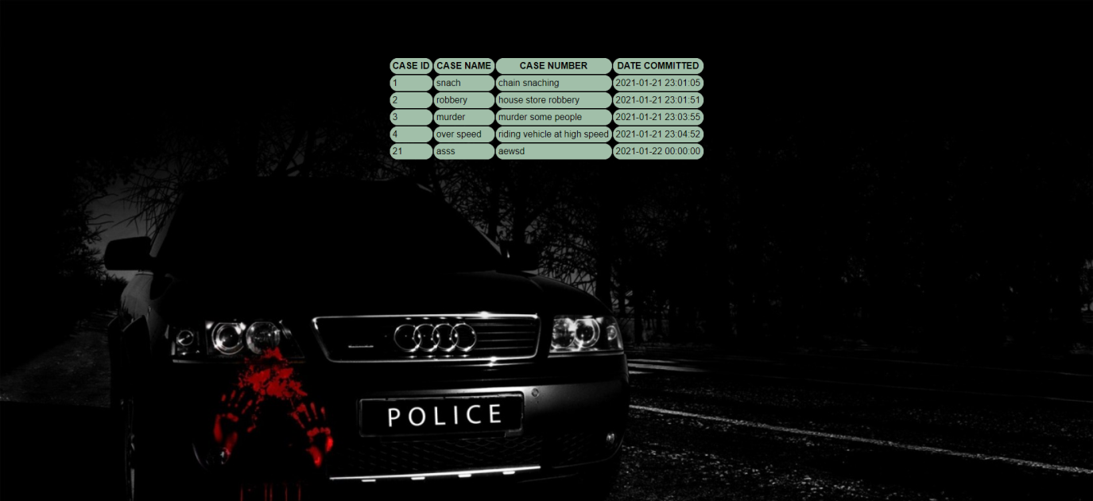

Fig no. 12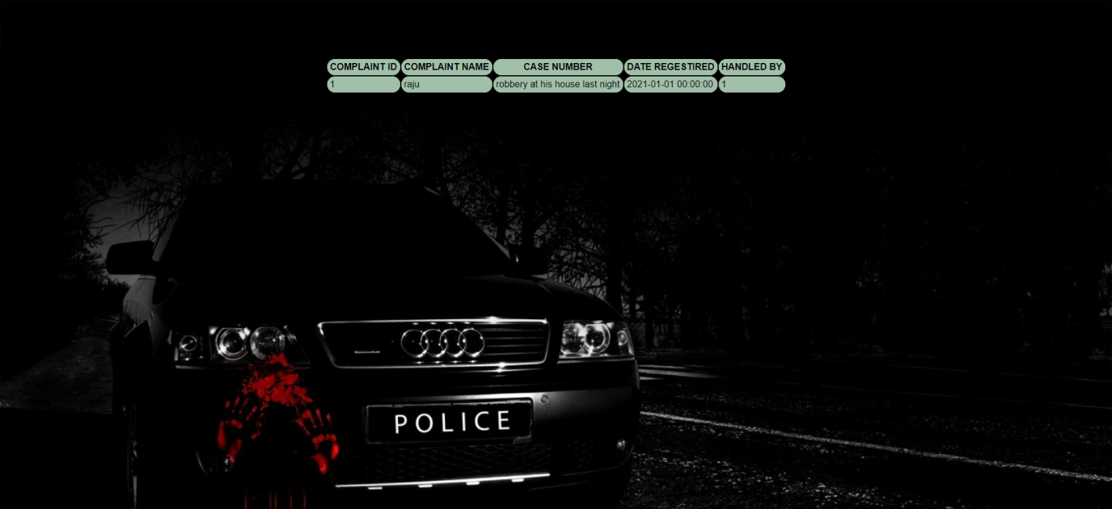

Fig no.13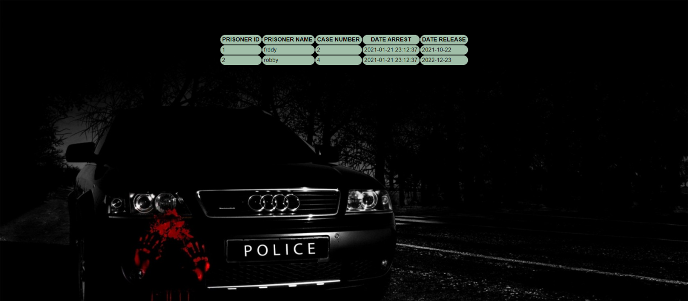

Fig no. 14



Fig no.15



Fig no. 16



Fig no 17



Fig no. 18



Fig no. 19

**Chapter 6**

**CONCLUSION**

To conclude . Police database management system is build for the easy store of data through the server and retrieve the data needed.

Now a days all the data are stored the data from different location and different system.

So if have a good system from storing of web to the local storage or to the cloud storage

This project achieves the important goal of generating a Separate police_id , prisoner_id , complaint_id , case_id , criminal_id…etc, thus making it easy for the police database to keep records, and thus manage their records. As it provides web-view , its useful for the user to improve all Services.

**Chapter 7**

**FUTURE ENHANCEMENTS**

FOR THE FUTURE, THE PROJECT WILL BE IMPLEMENTED TO

* THE ADMIN COMPATIBILITY
* SECURITY FOR THE DATA
* BETTER USER-INTERFACE
* BETTER OPTIONS
* BETTER GRAPHICS
* MORE DATA IN TO THE DATABASE
* MERGING OF THE MORE DATABASE FOR REDUCE THE TIME CONSUMPTION
* AND GETTING ALL DATABASE INTO ONE PAGE AND DIRECTED TO THE NEXT.

**Chapter 8**

**REFERENCES**

**Books**

* Fundamentals of Database Systems, Ramex Elmarsi and Shamkath B . Navathe , 7th Edition, 2017, Pearson
* Database management System , Ramkrishnan, and Gehrke , 3rd Edition , 2014 , McGraw Hill

**Websites**

* HTML: w3schools.com ,[youtube.com](https://www.youtube.com/) , [stackoverflow.com](https://stackoverflow.com)
* CSS : <w3schools.com> ,youtube.com , [stackoverflow.com](https://stackoverflow.com/)
* PHP: w3schools.com , youtube.com , [stackoverflow.com](https://stackoverflow.com/)
* NODEJS : w3schools.com ,stackoverflow.com, www.youtube.com, stackoverflow.com